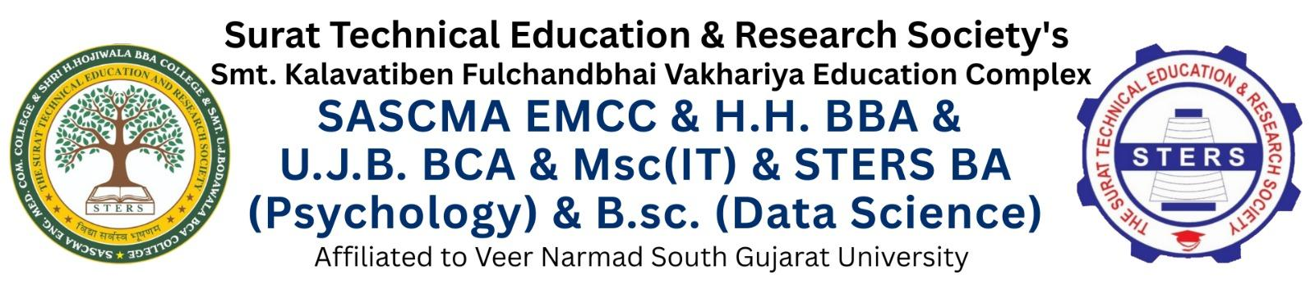

SY MSC(IT) [SEM-3]
Practical Journal
Year : 2025-26

Subject Code: | 305
Subject Name: | Practical – III (DS)
Roll No.: | 2021
Student Name: | Prince Sureshbhai Kahar
Class : | SY MSC (IT) [SEM-3]
Div: | A
Faculty Name: | Dr. Niteshkumar G. Patel
Faculty Sign.: | _______________
Date: | 30 / 10 / 2026

Index
SR. NO. | PROGRAM DEFINITION | PAGE NO. | SIGN
1 | Implement menu-driven program to implement Stack using Array to perform all basic operations: PUSH, POP, PEEK, isEmpty, isFull, and DISPLAY | 1
2 | Implement program to convert infix to postfix expression. | 4
3 | Implement Program to Evaluate Prefix Expression. | 6
4 | Implement menu-driven program to implement Simple Queue using Array to perform operations: INSERT (Enqueue), DELETE (Dequeue), PEEK, and DISPLAY. | 8
5 | Implement menu-driven program to implement Circular Queue using Array to perform operations: INSERT (Enqueue), DELETE (Dequeue), and DISPLAY. | 11
6 | Implement menu-driven program to implement Double Ended Queue (Dequeue) to perform operations for Input-Restricted and OutputRestricted Double Ended Queues using an array.
7 | Implement menu-driven program to implement Singly Linked List to perform operations including insertion & deletion (at given position), searching, traversal.
8 | Implement menu-driven program to implement Doubly Linked List to perform insertion, deletion, and forward/backward traversal operations.
9 | Implement menu-driven program to perform Searching Techniques to search for an element in an array using both Linear Search and Binary Search algorithms. | 14
10 | Implement menu-driven program to perform Advanced Sorting Techniques to sort an array of integers using Quick Sort and Merge Sort.

